Sprint Report  
Sprint 2 (Feb 8) Submission

Submission Date: 8 February 2021

Team A

Gregorson Mahon T00057640

Taylor Peck T00483746

Nicholas Piluso T00586492

Contents

List of tasks for the previous week 3

List of tasks for the coming week 3

Project Management Tool Screenshot 4

Updated Mock-ups or Other Relevant Documents 5

# List of tasks for the previous week

|  |  |
| --- | --- |
| Task Name | Responsible Team Member |
| **Begin development of SQL Database:** Created preliminary relational schema  **Continued research on available outage data:** Looked into scraping data for planned outages | Taylor |
| **Begin development of SQL Database:** Created preliminary ER diagram | Gregorson |
| **Begin development of the Application Server:** Created scripts to download and process the power outage information. | Nick |

# List of tasks for the coming week

|  |  |
| --- | --- |
| Task Name | Responsible Team Member |
| **Server Platform – explore server hosting options:** Options are to be discussed by team on Wednesday Feb 10th. | All Team Members |
| **Begin development on web server:** create preliminary web server interface & MVC components | Taylor |
| **Continue development of SQL Database:** Finish preliminary ER diagram, write SQL code to create database & tables, perhaps even implement the database if we can find a server to host everything in time. | Gregorson |
| **Continue development of the Application Server:** Develop ability to send emails, implement functions that create user messages, and connect the app server code to the database if we can find a server to host everything in time. | Nick |

# Project Management Tool Screenshot

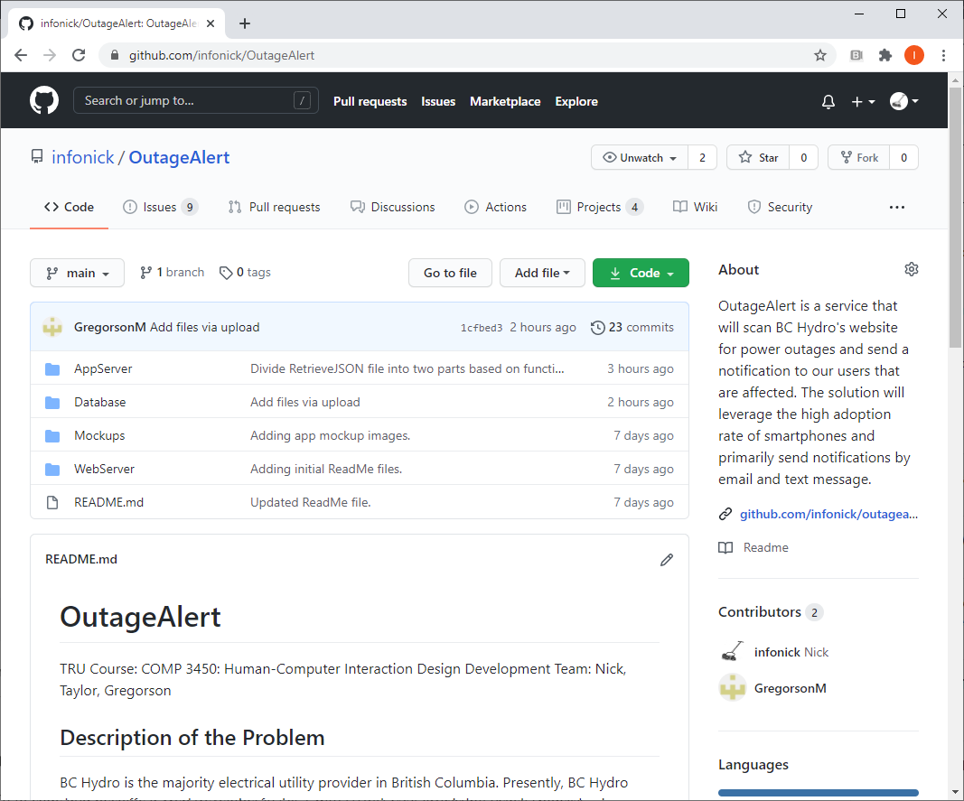

# Updated Mock-ups or Other Relevant Documents

Some of our preliminary database diagrams:

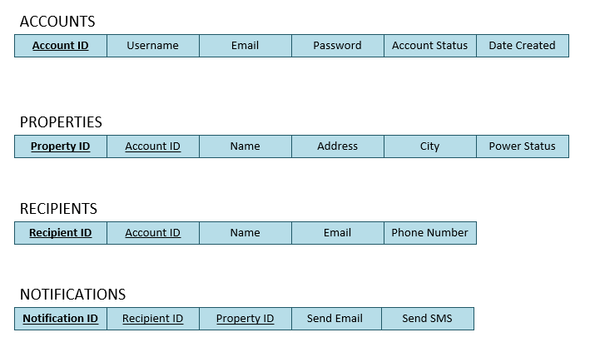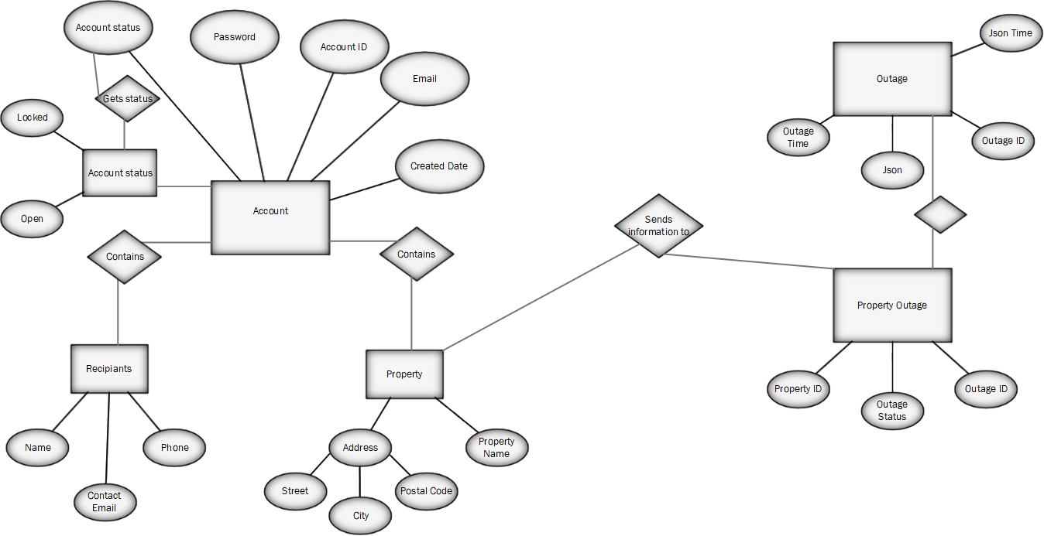

**Note:** User Interface mock-ups have not changed from what was originally submitted with the Project Idea.

Other documents available for review on GitHub: <https://github.com/infonick/OutageAlert/>